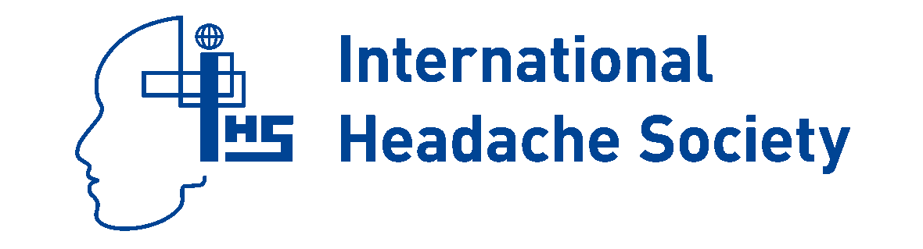

Affiliate Membership Renewal 2018
Sociedade Brasileira de Cefaleia--SBCe

Online-only membership

- Online subscription to Cephalalgia, published 14 times per year
- Online access to Cephalalgia and The Neuroscientist via the IHS website
- Access to the Online Learning Centre and the members’ pages of the IHS website
- Free download of Cephalalgia App
- Entitlement to apply for IHS Fellowships
- Early access to IHS guidelines and other publications

Membership number: ____________

Name ______________________________________________________________________________________

If any of your contact details have changed within the last 12 months, please include them here, otherwise please leave blank

____________________________________________________________________________________________

____________________________________________________________________________________________
Telephone: ______________________________________ Fax: ________________________________________
E-mail: _________________________________________

To keep our costs low, most of our communication is now done by email. Please ensure you provide an up to date email address.

Affiliate Society

I confirm I am a member of SBCe.

Membership fees (US$ 99) should be paid to IHS.

Method of payment
Membership is on a calendar-year basis.

Please charge my: VISA Eurocard/Mastercard AmEx for US$ 99.00

Card no: ______________________________________________ Expiry date: _________________________

Name (as on card): ______________________________________________________________________

Signature: ______________________________________________________________________________

Send to: International Headache Society, 52–53 Russell Square, London WC1B 4HP UK.
E-mail: carol.taylor@i-h-s.org; Fax: +44 207 504 8788

